Job Description:
Learning Support Assistant (Level 2)

Mission and Values

“Helping people living in extraordinary circumstances to live ordinary lives”
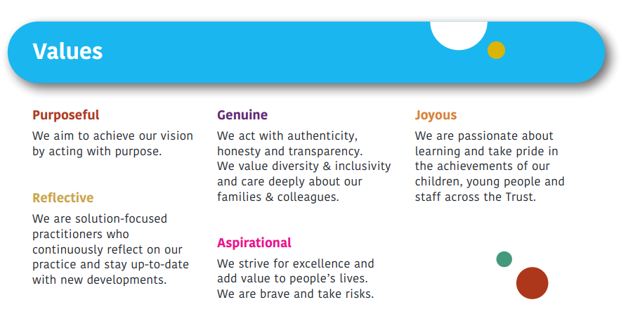

Learning Support Assistants (LSAs) at Kingsley Learning Foundation are vital to the success of our schools. They play a crucial role in providing support to our pupils with special educational needs and disabilities (SEND). If you are that special someone who can give our wonderful pupils the best support possible, please see the description of the role below.

Teaching and Learning
- Individual Support: To provide individual or group support to pupils, aiding them in accessing the curriculum, and developing their social, emotional, and life skills.
- Behaviour Management: To support pupils in developing positive behaviours and increasing their availability for learning.
- Communication Support: To support pupils with communication challenges to develop social interaction skills using the most suitable mode for each learner.
- Personal Care: To provide personal care needs for pupils, including toileting, feeding, and dressing.
- Wider Support: To engage with pupils during unstructured times, assisting them to access opportunities for joyous play, and fostering relationships.
- Curriculum Delivery: To aid teachers in delivering purposeful lessons and activities tailored to pupils' individual needs, promoting engagement, well-being and independence.

Working with others
- Team work: To demonstrate good interpersonal relationships and communicate effectively as part of a class and wider school team.
- Communication: To effectively communicate with families to share pupil progress and successes, as well as giving professional, genuine feedback regarding pupils daily presentation in class
- Professionals: To collaborate with professionals to support holistic child development.

School and Classroom Processes
- Safeguarding: To follow safeguarding policies and procedures. Complete training relating to safeguarding, manual handling and health and safety. To manage my own and pupil welfare effectively.
- Preparation: To prepare materials and resources for lessons and activities.
- Documentation: To maintain records of pupil progress.

Our LSAs work closely with teachers, other LSAs, therapists, and a range of other professionals to ensure that our pupils receive the support they need to achieve their full potential.

Person Specification: Learning Support Advisor (Level 2)

CRITERIA | ESSENTIAL QUALITIES | DESIRABLE QUALITLIES
Knowledge/Experience | - A desire to build a nurturing and supportive learning environment for pupils  - A knowledge of safeguarding, confidentiality, security and data protection.  - An ability to respond to the emotional needs of pupils. | - Experience of working in a school/special school setting  - Experience and/ or knowledge of working with children and young people with SEND  - General understanding of national curriculum and other basic learning programmes
Skills/Abilities | - Remaining calm and positive in challenging situations.  - Ability to act on own initiative.  - Ability to motivate and encourage pupils.  - Good interpersonal and communication skills  - Solution-focused | - Ability to observe and monitor progress and maintain records.  - Good computing skills
Qualification/Training | - NVQ level 2 or equivalent qualification in a relevant subject, accredited by an Ofqual registered body (please note certificates of completion are NOT acceptable).  - Minimum GCSE Grade C in Maths and English or equivalent.  - Demonstrable experience of working with or caring for children. | - Basic knowledge of first aid  - Knowledge of de-escalation techniques  - Appropriate computing and technology skills  - Safeguarding training
Personal qualities | - An active listener  - Calm, patient  - A good sense of humour  - Team player  - Flexible attitude  - Commitment to continuous professional development | - Ambition to progress

