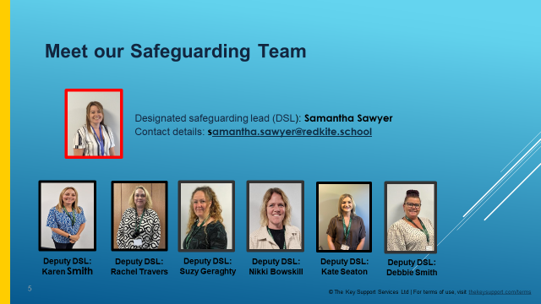
​As we begin the New Year, I would like to remind you that safeguarding is our top priority at Red Kite Special Academy.

We are dedicated to promoting the welfare of children and young people, and we expect all staff, parents, visitors, and volunteers to share this commitment. We are fully committed to implementing consistent and effective safeguarding procedures to support families, children, and staff at our school.

Everyone who comes into contact with the children and families in our community plays an important role. Everything we do centres around the children. Their safety, well-being, achievement, and happiness are foundational to every decision we make.

At Red Kite, we ensure that all staff are highly trained in all aspects of safeguarding, with regular updates and refresher training throughout the year. We also incorporate age-appropriate opportunities within our curriculum to teach children how to keep themselves healthy and safe.

In this first issue of our safeguarding newsletter, we will reintroduce you to the school’s Designated Safeguarding Team.​
.

Reporting concerns
If you have a concern about the welfare of a child within our school, please speak to a Designated Safeguarding Lead or any member of staff. You can also contact the Multi-Agency Safeguarding Hub (MASH) to report concerns by calling 0300 126 3000. This line is also manned during evenings and weekends. Alternatively, safeguarding concerns for a child can be shared with the NSPCC by calling 0808 800 5000, emailing help@NSPCC.org.uk or completing an online form by visiting www.nspcc.org.uk.

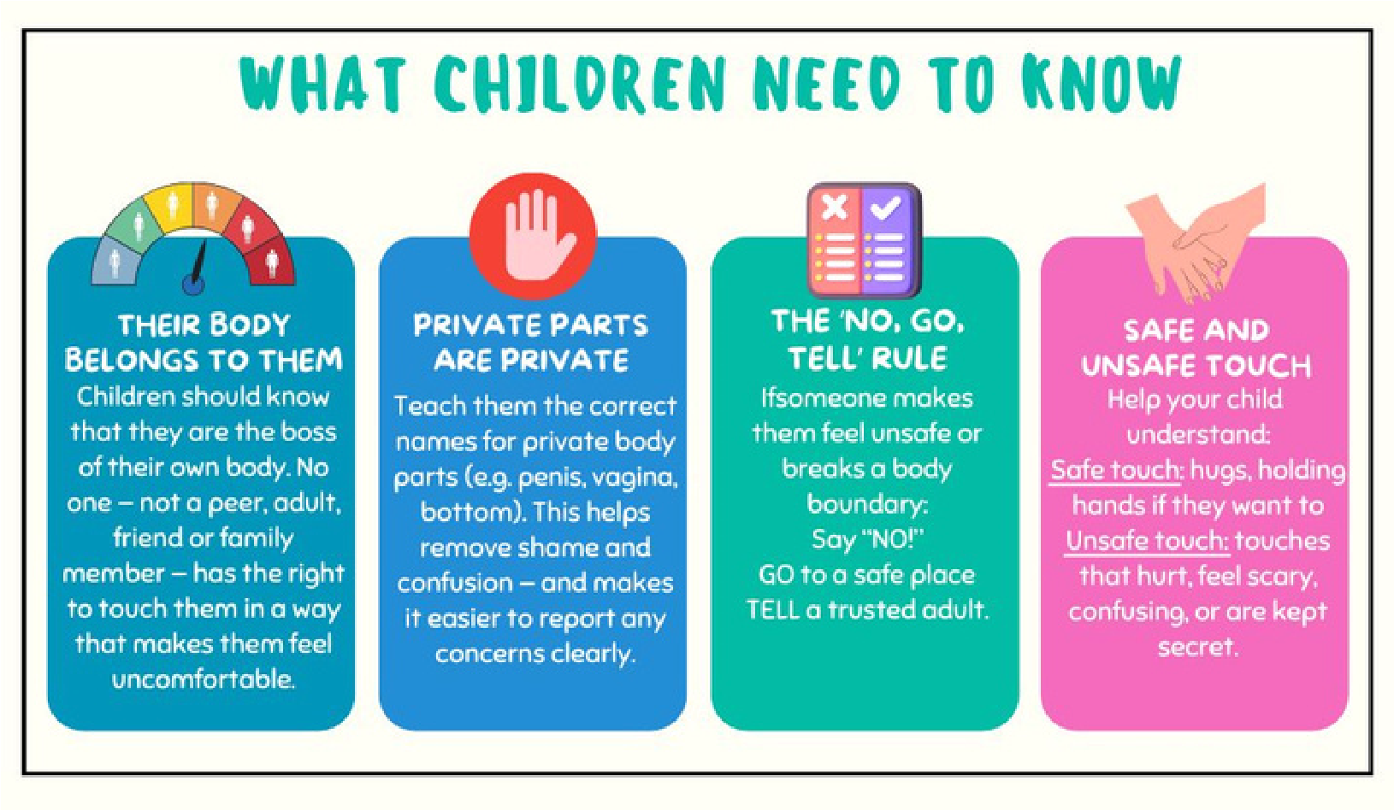
Useful Websites
Childline: https://www.childline.org.uk/ UK Safer Internet Centre: https://saferinternet.org.uk/ Children’s 0-19 Team: https://www.nhft.nhs.uk/0-19/ NSPCC: https://www.nspcc.org.uk/ Childnet: https://www.childnet.com/ Place2Be: https://www.place2be.org.uk/ ThinkUKnow: https://www.thinkuknow.co.uk/ Mind: https://www.mind.org.uk/ Barnardo’s: https://www.barnardos.org.uk
How we can support
Our broad, balanced and diverse curriculum gives Red Kite pupils the chance to experience life in all its diversity, to acquire knowledge, understanding and skills that significantly impact on personal development, behaviour and welfare; thus, equipping every child with the knowledge and skills required to keep themselves safe, happy and healthy both now and in their future.
We also provide additional support in many ways to ensure that all pupils are able to know how to keep themselves safe, also encouraging them to share any worries and concerns. Some of examples of this support are:
- NSPCC Speak Out Stay Safe visits and workshops
- PHSE across the school
- Comprehensive curriculum coverage
- lessons/workshops/assemblies
- Promoting national campaigns such as Anti-Bullying Week; Children’s Mental Health Week; Safer Internet Day and completing various activities to raise awareness

Our safeguarding and pastoral team maintains an open-door policy for children and families. We also facilitate access to support from external agencies, including School Nursing/Health Visitor services and Early Help services. Additionally, we make referrals to the Children with Disabilities team to help with additional support.

How you can support your child/young person

Helping your child understand personal boundaries and safety is so important for keeping them safe. Talking about body safety might feel a little awkward, but it’s one of the best ways to empower them. When child know about their bodies, boundaries, and rights, they gain confidence and are more likely to speak up if something doesn’t feel right. You don’t have to have a long, serious talk—short, casual conversations can work wonders! Here are some friendly conversation starters you can try
- “Do you know what parts of your body are private?”
- “If someone made you feel uncomfortable, who would you tell?”
- “Has anyone ever asked you to keep a secret that made you feel funny or unsure?”
- “You’re allowed to say ‘no’ to hugs or kisses, even to family – how do you feel about that?” “What would you do if someone touched you in a way you didn’t like?
- ” Use natural moments (e.g. bath time, getting dressed, bedtime stories, a walk in the park) to bring up the topic gently. Keep your tone calm and reassuring. The goal is to help children feel safe, heard and empowered. Reassure them: “You can always talk to me about anything – I’ll always listen and help.”

Our Policies: For a copy of our school’s Child Protection Policy, and other related safeguarding policies, please visit the safeguarding page(s) on our school website:

